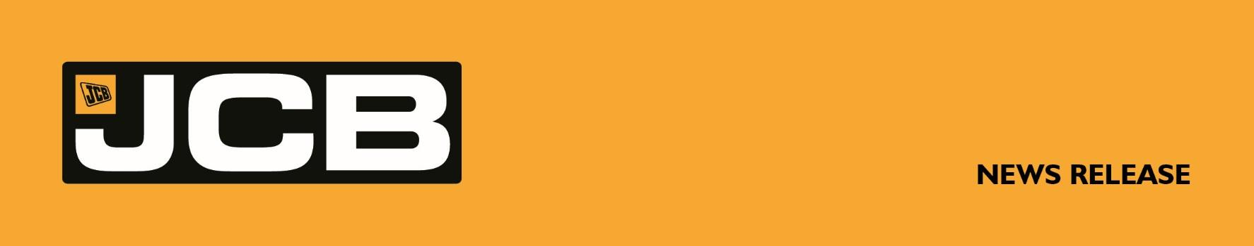

NC-5377 September 28th, 2026

JCB INVESTS FOR THE FUTURE AFTER HYDROMAX WORLD RECORD
Fresh from setting a new world land speed record of 406.320mph powered by its pioneering hydrogen technology, JCB is accelerating investment in its future, with major commitments to British manufacturing and new production capacity in the United States.

The manufacturer is investing heavily in the transformation of its Staffordshire World HQ, while in the USA, JCB’s new factory in San Antonio, Texas - its largest in the world - opens next month, creating 1,500 jobs over the next five years.

As JCB invests for its next chapter, George Bamford is to become Joint Chairman of the family company alongside his father, Lord Bamford. It is the first change at the top of JCB in more than 50 years, during which the business has grown from its Staffordshire roots into one of Britain’s largest privately owned manufacturers, with 23 factories and more than 20,000 employees worldwide.

The announcement coincides with JCB reporting a resilient performance in 2025, despite mixed market conditions and geopolitical headwinds around the world. Sales turnover totalled £5.7 billion, profit before tax was £642 million and machine sales reached 113,498 units, while the business remained debt-free with no net borrowings. JCB also increased its global market share, despite flat demand in North America and a 12% market contraction in India.

At the heart of JCB’s investment in Britain is the £100 million transformation of its Staffordshire headquarters – JCB’s home since 1950, when Joseph Cyril Bamford moved production into a former cheese factory in Rocester. A £60 million fully automated powder paint plant and a comprehensively modernised shop floor are part of the transformation, helping to secure the future of more than 8,000 UK jobs.
More . . . .

2/ . . .
In the USA, JCB’s new $1 billion factory in San Antonio, Texas – at one million square feet, JCB’s largest factory in the world – opens next month. It will build Loadall telescopic handlers and access equipment for North America, the world’s biggest construction equipment market.
Investment in factories is being matched by investment in innovation. Hydrogen-powered machines are now in production following JCB’s £100 million programme to develop hydrogen combustion technology, making it the first construction equipment company in the world to bring a fully approved hydrogen-fuelled combustion engine to market.
Last month, those engines powered JCB into the record books at the Bonneville Salt Flats in Utah. The JCB Hydromax, driven by Wing Commander Andy Green OBE, recorded 406.320mph (653.909km/h) on the Salt Flats to become the fastest ever hydrogen-powered vehicle – more than doubling the previous hydrogen combustion record and beating JCB’s own Dieselmax diesel record, set 20 years earlier. JCB Hydromax was powered by two production-based hydrogen engines manufactured at JCB’s factory in Foston, Derbyshire, and went from idea to world record in just 18 months.
Meanwhile, the JCB Academy, a pioneering project championed by Anthony Bamford to address the UK’s engineering skills shortage, goes from strength to strength. This year 708 students applied for 314 places available this September, maintaining the Academy’s long-standing reputation for being heavily oversubscribed. Since opening in 2010, it has educated around 3,750 young people and boasts a 100% record of leavers progressing into employment or further education. This month a total of 116 new apprentices, undergraduates and graduates, selected from more than 6,300 applicants, also joined JCB.

JCB Chairman Lord Bamford said: “Last year JCB celebrated its 80th birthday and, as we look ahead, we are investing heavily in the future of the business – from the transformation of our Staffordshire headquarters and pioneering hydrogen technology, to our new factory in Texas. As part of that next chapter, I’m delighted that my son George will become Joint Chairman of JCB. We have never been a company that stands still, and these investments will ensure JCB is well placed to seize the opportunities ahead.”
More . . . .

3/ . . .
George Bamford said: "From the day my grandfather founded JCB in 1945, innovation and investment in Great Britain has been at the heart of everything we do. JCB Hydromax showed the world what British engineering can achieve. That same spirit is in every machine we build. While JCB has expanded globally over the years, our home has always been here, and the record investment we are making in our facilities and in new products is good news for Britain and good news for JCB."

JCB CEO Graeme Macdonald said: “While 2025 was a more challenging year with mixed market conditions around the world, JCB delivered a robust performance overall. Machine sales were down by around 5%, but turnover remained broadly stable due to a more favourable market and product mix. Despite nil market growth in North America and a 12% market contraction in India – both important markets for JCB – we increased our global market share during 2025, which is an encouraging result. The overall outlook for 2026 is for moderate growth, despite ongoing geopolitical uncertainty, and with new capacity coming on stream in Texas and Staffordshire we are well placed to take advantage of it."

JCB 2025 annual results at a glance:
 | 2025  (in £s Sterling) | 2025  (in US$) |  | 2024  (£)
Turnover | £5.7 billion | $7.64 billion |  | £5.8 billion
Profit before tax | £642.0 million | $860.2 million |  | £687.3 million
Machine sales (units) | 113,498 | $1.34/£1 |  | 119,848

Ends
For further information contact: Nigel Chell, JCB Press Office
Tel: 01889 593592 E-mail: nigel.chell@jcb.com www.jcb.com

