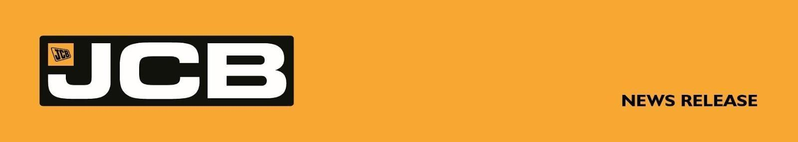
NC-5375 August 2026

SELECT PLANT HIRE STRENGTHENS PARTNERSHIP WITH JCB WITH £5 MILLION ORDER
Select Plant Hire has further strengthened its long-standing relationship with JCB with a £5 million investment in new equipment - reinforcing its commitment to supporting major UK construction projects with modern, high-performance machinery.
Part of the Laing O'Rourke Group, Select Plant Hire is one of the UK's leading providers of plant, equipment and accommodation services, supporting major infrastructure, building and engineering projects across the country.
The latest order, supplied through dealer Greenshields JCB, includes JCB 370X tracked excavators, JCB 245XR reduced tailswing excavators, JCB 145XR reduced tailswing excavators, 9T dual-drive site dumpers, and JCB Loadall telescopic handlers.
The machines have been selected to support a wide range of construction applications and will further enhance Select Plant Hire's ability to support a growing number of major UK projects. The investment reflects the company's continued focus on operating modern, productive and reliable equipment, capable of delivering the highest standards of performance, safety and efficiency on site.
Business Stream Leader - Plant and Power Solutions, Select Plant Hire, Warren Wilkinson said: “Investing in our fleet is critical to ensuring we can continue to support our current clients and expand our pipeline with modern, reliable and high-performing plant. This order reflects our confidence in the pipeline ahead and the strength of our long-standing relationship with JCB and Greenshields JCB. Their product quality, innovation and service support give us the confidence to keep investing in equipment that delivers for our projects and customers."
JCB Global Major Accounts MD Steve Fox said: “This is a fantastic order and a strong reflection of the partnership we have built together. Ultimately, it comes down to two things: the quality of JCB’s machines and the strength of our after sales support.
More . . . .

2/ . . .
“Select Plant Hire places exceptional demands on its equipment, and JCB machines are built to deliver the performance, reliability and durability required on major construction projects. Just as importantly, we work closely with the Select team to ensure they have the right machines, backed by the right support, to maximise value throughout their working life.
“This £5 million investment represents a significant vote of confidence in JCB and underlines the strength of our relationship with Select Plant Hire. We look forward to continuing to support them as they deliver some of the UK’s most important construction and infrastructure projects.”
JCB X Series excavators have been chosen for their combination of productivity, operator comfort, fuel efficiency and durability. The JCB site dumpers and Loadall telescopic handlers will provide Select Plant Hire with a highly versatile fleet capable of meeting the demands of some of the UK's most significant construction and infrastructure schemes.
The investment marks another milestone in the partnership between Select Plant Hire, Greenshields JCB and JCB, supporting a shared commitment to innovation, productivity and delivering world-class equipment solutions for the UK construction industry.
Caption: Pictured left to right are Warren Wilkinson, Business Stream Leader - Plant and Power Solutions, Select Plant Hire and James Atley, Sales Director, Greenshields JCB.

https://www.selectplanthire.com/

ENDS
For further information contact:
Nigel Chell, JCB Press Office Tel: 01889 593592 Email: nigel.chell@jcb.com

