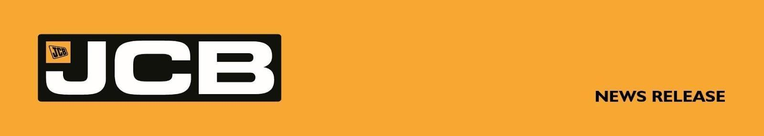
NC-5374 6th August 2026
JCB HYDROMAX POWERS TO 368.347MPH ON ROAD TO FIA RECORD ATTEMPT

JCB's hydrogen-powered Hydromax streamliner today clinched an SCTA speed record on the Bonneville Salt Flats – reaching 368.347mph at the world's leading land speed racing event.

Driven by Wing Commander Andy Green OBE, the car set a new record in the Southern California Timing Association’s (SCTA) Blown Gas Streamliner (AA/BGS, 500+ cubic inches) class at Bonneville Salt Flats at 8:50am today (MDT), recording a speed of 368.347 mph.

The success came as the engineering giant gears up for an official FIA world record attempt next week.

The run was completed as part of the Southern California Timing Association's (SCTA) renowned Bonneville Speed Week, regarded as the world's premier land speed racing event, which requires teams to make two runs on consecutive days and takes the average of the maximum speeds reached.

JCB Chairman Lord Bamford said: “To reach 368.347mph is a fantastic achievement for the whole JCB Hydromax team. It shows just what JCB’s hydrogen engines are capable of ahead of our outright FIA world record attempt. This project is about proving that hydrogen power can perform at the very highest level with zero emissions, and today’s result is powerful evidence of that.”

Andy Green, the fastest man on earth at 763.035mph and the only person to break the sound barrier on land, said: “It has been an absolute joy to be back on the salt, racing at Speed Week alongside some incredible teams. The Bonneville Salt Flats are the home of the World Land Speed Record, where racers get to push the boundaries of physics and innovation. This record has given all of us huge confidence in the car, the team and the quality of the engineering. With our first record in the bag, we're now turning up the power on the engines, aiming to go even faster next week.”

JCB Hydromax Project Leader Ryan Ballard said: “Speed Week is one of the most iconic and respected events in world motorsport, bringing together competitors from around the globe who share a passion for pushing the boundaries of engineering and performance.
“We are immensely grateful to the Southern California Timing Association for the professionalism, expertise and enthusiasm with which they organise this unique event. The SCTA's commitment to land speed racing has created a platform where innovation can thrive and records can be challenged. It has been a privilege for JCB to compete here, and we'd like to thank everyone involved for making us feel so welcome as we strive towards even greater achievements on the Salt Flats.”

Yesterday the 32 foot long, twin-engined JCB Hydromax recorded a speed of 367.141mph and today reached a maximum speed of 369.554mph, giving an average speed of 368.347mph, setting a new SCTA record on the Bonneville Salt Flats. The result surpasses the previous SCTA record of 348.342 mph set by the Spectre Streamliner in 2010, marking the first time in 16 years the class record has been broken.

With the SCTA challenge behind it and valuable data gathered, the JCB team is now focussing on next week's outright Fédération Internationale de l’Automobile (FIA) world record bid, where the JCB Hydromax will attempt to write a new chapter in hydrogen-powered motorsport history.

JCB Hydromax is powered by two of JCB’s own production-based hydrogen internal combustion engines. With the engines now being turned up towards their full combined output of 1,600hp, the team will look to build on this SCTA record as it prepares for the FIA record attempt next week.

Bonneville Speed Week is the world's leading land speed racing event, run by the SCTA, which governs and verifies official class records at the event. Following Speed Week, the JCB Hydromax team is remaining at Bonneville to pursue officially recognised world records under the FIA, the global governing body for motorsport. The JCB Hydromax team has been running to a strict test programme, completing 44 runs to date, building speed and confidence in the car as they push the limits of hydrogen combustion technology and showcase British engineering to a global audience.

JCB’s speed attempt comes ahead of the opening of the company’s new $500 million, one million sq. ft, 400-acre factory in San Antonio, Texas, which will employ 1,500 people, manufacturing machines for the US market.
JCB has a long history of pushing the limits of speed. In 2006 JCB’s Dieselmax streamliner clinched the world diesel land speed record, reaching 350.092 mph on the Bonneville Salt Flats powered by two JCB diesel engines. In 2019, the JCB Fastrac tractor was crowned the world’s fastest tractor at 135.191 mph, while in 2014 the JCB GT set the world record for the fastest backhoe loader at 72.58 mph.

ENDS
For further information contact:
Jules Tipler / Nik Ellwood
jcbhydromax@wearenameless.co.uk
Newsroom/images: https://jcb.com/jcbhydromaxnews

About JCB
JCB, the world’s third largest construction equipment brand by volume, has 22 plants on four continents: 11 in the UK and others in India, Brazil, the USA and China. JCB is a family company, which was founded on October 23rd, 1945, by the late Joseph Cyril Bamford CBE. His son Anthony, now Lord Bamford, has been Chairman since 1975. JCB has just celebrated its 80th birthday.

In 2021, JCB unveiled its first ever prototype products powered by hydrogen: a backhoe loader and a Loadall telescopic handler. JCB’s purpose-engineered zero CO_{²} hydrogen engine was designed after a challenge to the company’s engineers from Lord Bamford. As part of a £100 million investment, a team of 150 engineers has been working on the exciting hydrogen engine project and more than 150 JCB hydrogen combustion engines have so far been produced, with the first machines now in production.

