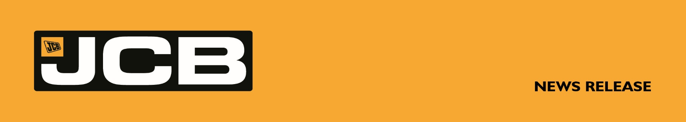NC-5368 JULY 2026
NEW YORK AWAITS AS TOM IS CROWNED JCB OPERATOR OF THE YEAR
A Derbyshire plant operator is heading to New York after being crowned JCB Operator of the Year 2026 in a national competition.
Tom Balls, of JC Balls & Sons, won a three-night trip for two to the Big Apple, complete with $5,000 spending money, after defeating 20 other finalists from across the UK in the JCB Operator Challenge final at Kevin Quarry in Staffordshire.
Having qualified through the TC Harrison JCB regional heat, Tom came out on top after a series of timed challenges designed to test speed, precision and machine control using a JCB 145XR tracked excavator, JCB 3CX PRO backhoe loader and JCB 25Z-1 mini excavator.
Lewis Cameron, of AJ Rennie in Banff, Scotland, finished runner-up after qualifying through Scot JCB, while Ollie Gunns, of Hampshire-based Gunns Contractors Ltd, took third place after progressing through the Greenshields JCB heat.
Tom said: "I'm still in shock. The standard of operator in the final was fantastic and I can't believe I've won. I'm already excited about the trip to New York. I was surprised how fast I completed the challenges and felt really confident in the various JCB machines."
The JCB Operator Challenge attracted hundreds of entrants from across the UK, with competitors battling through seven regional heats hosted by JCB's dealer network. The top three operators from each heat earned a place in the national final, where they faced a series of challenges designed to demonstrate the skill, accuracy and control required by today's professional operators.
As champion, Tom wins a three-night trip for two to New York, including flights, hotel accommodation and $5,000 spending money. Lewis receives two tickets to the England v New Zealand Autumn Internationals rugby fixture, while Ollie wins a two-night stay in Edinburgh with £500 spending money.
ENDS
For further information contact: Nigel Chell, JCB Press Office,
Tel: 01889 593592, Email: nigel.chell@jcb.com, www.jcb.com

