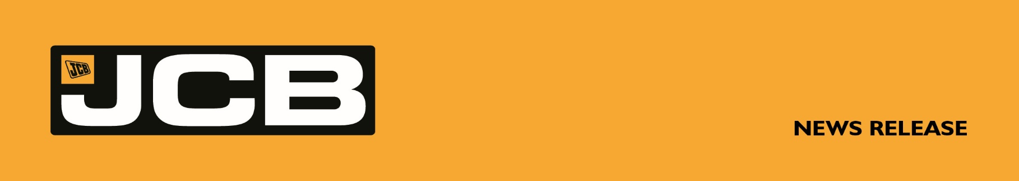
JCBA-0004 JUNE 2026
JCB PARTS ONLINE PASSES 50,000 PRODUCT MILESTONE
JCB Parts Online has passed a major milestone with 50,000 lines now available.
The platform - parts.jcb.com/uk – provides JCB customers with anytime access to a wide range of genuine components including: powertrain parts, electrical systems, filters, lubricants, ground engaging tools, cab and body parts and attachments, backed by the company’s global dealer network.
JCB Group Managing Director - Global Aftersales, Mario Moser, said: “Machine uptime remains critical across every sector JCB serves. When parts need replacing, fast access and guaranteed compatibility are essential to maintaining productivity. JCB Parts Online continues to evolve in direct response to customer requirements, making it quicker and simpler to identify and order genuine parts and attachments.
“Expanding the platform to more than 50,000 products helps customers source the exact components for their machine. By improving availability, accuracy and convenience, JCB Parts Online is helping customers maximise uptime, profitability and sustainability across their operations.”
Family run Green Power Plant Hire Ltd is an active user of the JCB e-commerce solution, purchasing parts for its fleet of more than 200 JCB construction machines.
Green Power Plant Hire Owner, David Green said: “JCB makes life easy for us and ensures we have the support we need to manage our fleet. We find ordering online fast and convenient, helping ensure our JCB machines are always well maintained and operating efficiently. Parts Online is linked to our JCB dealer account at Watling JCB. It means we can get direct delivery of genuine JCB parts or choose to click & collect from our local Watling JCB depot.”
Customers can register now at: https://parts.jcb.com/uk
ENDS
For further information contact: Ben Brookes
07730 600483 | ben@brookesandsowerby.co.uk

