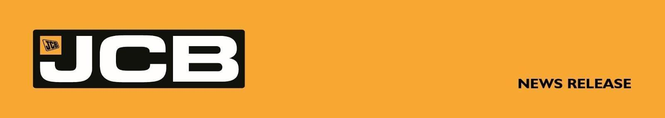
NC-5361 June 25th 2026
JCB HYDROMAX HITS 208MPH AS UK TESTING SUCCESSFULLY CONCLUDES
British engineering giant JCB has successfully completed UK testing of its hydrogen-powered JCB Hydromax car – reaching 208mph and clearing the way for its world land speed record attempt at Bonneville next month.
The shakedown runs at RAF Wittering in Cambridgeshire, England saw the 32-foot car driven by Wing Commander Andy Green OBE reach 208mph under its own hydrogen power – up from the 177mph recorded earlier in the programme. The testing finished yesterday.
Just as valuable as the speed is what the team has gained: vital data, hard-won engineering insight and the teamwork and communication that can only be built on the track. The crew also refined JCB Hydromax’s hydrogen refuelling process – a key element in ensuring fast, efficient operation on the Bonneville Salt Flats, where turnaround times can decide whether a record run goes ahead. All of it will prove invaluable in Utah in August.
JCB Chairman Anthony Bamford said today: “The UK testing programme has given us everything we had hoped for and more. We have a car that runs, a crew that knows it inside out and a wealth of real-world data that no amount of theory could ever provide. The team has done a magnificent job and our focus now turns entirely to the Salt Flats and a new world hydrogen land speed record.”
JCB Engineering Director Ryan Ballard, who is leading the project, said: “Reaching 208mph is a tremendous result, but the real value of these tests is what we have learned. We now understand how the car behaves under load, we have refined our hydrogen refuelling, and we have built the teamwork and communication that will be decisive at Bonneville. Every refuel, run and tyre change we have rehearsed here is one we won’t be doing for the first time on the salt. We will arrive fully prepared, with a car and a crew that know exactly what they are doing.”
Andy Green said: “To run JCB Hydromax up to 208mph here in the UK is hugely encouraging. The car feels strong and the team has gelled brilliantly. Now comes the real challenge – Bonneville, the spiritual home of the World Land Speed Record. I can’t wait to get out on the salt.”
More . . . .

2/ . . . .
Unveiled at JCB’s World HQ in Staffordshire on May 12th, the car is powered by two of JCB’s own production-based hydrogen digger engines producing a combined 1,600 bhp. Just six weeks on, with UK testing complete, it will now be prepared for the journey to the United States.
Lord Bamford has spearheaded the company’s £100 million investment in hydrogen-powered internal combustion engines, which now power diggers rolling off production lines.
At Bonneville in 2006, Andy Green – the fastest man on earth at 763.035 mph and the only person to break the sound barrier on land – drove the JCB Dieselmax car to its Fédération Internationale de l’Automobile (FIA) diesel world land speed record of 350.092 mph, powered by two JCB engines. That record still stands, and JCB aims to beat it with the lighter, more powerful JCB Hydromax.
In Utah, the team will compete at SpeedWeek, run by the Southern California Timing Association (SCTA), before pursuing an officially recognised record under the FIA.
The record bid comes ahead of the opening of JCB’s new $500 million factory in San Antonio, Texas. JCB has long pushed the limits of speed: in 2019 the JCB Fastrac became the world’s fastest tractor at 135.191 mph, and in 2014 the JCB GT set the backhoe loader record at 72.58 mph.
ENDS
For further information contact: Nigel Chell JCB Press Office Tel: 01889 593592
E-mail: nigel.chell@jcb.com
Jules Tipler / Nik Ellwood
jcbhydromax@wearenameless.co.uk
Images can be found on the JCB Newsroom: https://www.jcb.com/jcbhydromaxnews
About JCB
JCB, the world’s third largest construction equipment brand by volume, has 22 plants on four continents: 11 in the UK and others in India, Brazil, the USA and China. JCB is a family company, which was founded on October 23rd, 1945, by the late Joseph Cyril Bamford CBE. His son Anthony, now Lord Bamford, has been Chairman since 1975. JCB has just celebrated its 80th birthday.
In 2021, JCB unveiled its first ever prototype products powered by hydrogen: a backhoe loader and a Loadall telescopic handler. JCB’s purpose-engineered zero CO_{²} hydrogen engine was designed after a challenge to the company’s engineers from Lord Bamford. As part of a £100 million investment, a team of 150 engineers has been working on the exciting hydrogen engine project and more than 200 JCB hydrogen combustion engines have so far been produced, with the first machines now in production.

