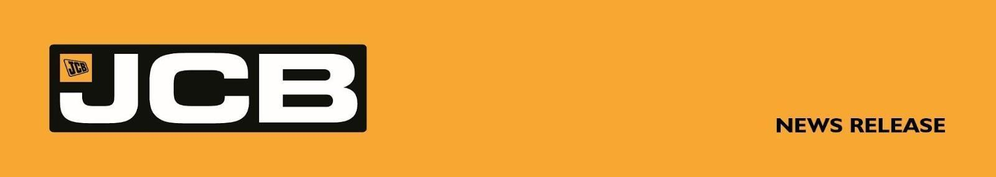
NC-5348 JUNE 2026 CHESHIRE FAMILY FIRM PLACES £18 MILLION MACHINE ORDER WITH JCB
A Cheshire family business which started with a single borrowed machine has placed an £18 million order for new equipment from JCB.
ASHBROOK was founded by James Ashbrook in 1998, initially undertaking farm contracting and groundworks using a machine borrowed from his father. Today, the plant hire company supplies equipment to the construction, agricultural and earthmoving sectors and operates a fleet of more than 3,000 machines. It employs more than 90 people across bases in Congleton and Warrington.
The latest investment sees the company purchase almost 270 machines from neighbouring manufacturer JCB. The order includes the company’s first ever X Series tracked excavators, alongside Loadall telescopic handlers, site dumpers and compaction equipment and marks the largest single JCB order in the company’s history. The machines are being supplied by dealer Gunn JCB and financed through JCB Finance.
Managing Director James Ashbrook said: “We are extremely proud of how our family company has grown over the past 28 years into one of the most respected plant hirers in Cheshire, Staffordshire and the North-West, with a strong reputation for excellent customer service. We are now hiring a wide range of JCB machines including dumpers, Loadall telescopic handlers, excavators, rollers and powered access.
“We’ve built an amazing team here over the years who frequently go above and beyond for our customers and who take genuine pride in the quality of our machines, we couldn’t have had the success we’ve had without the people who work for us and to repay that commitment it is important to us to buy quality reliable machines from premium suppliers who stand by their word to make sure our staff have the backup they need to deliver top quality hire services to our customers.
More…

2/…
“We bought our first JCB machine in 2013 and have progressively increased the size of our JCB fleet ever since. For the first time, we are investing in JCB X Series tracked excavators with the purchase of 145XR, 220X and 370X models. They have built an enviable reputation in the market, giving me real confidence that they will prove a valuable addition to our fleet and further enhance the service we provide to our customers.
“This is also our first JCB compaction equipment order, including soil compactors, strengthening our ability to deliver reliable, high-performance compaction solutions for hire.”
JCB Global Major Accounts MD Steve Fox said: “We are extremely proud of the continued growth of our partnership with ASHBROOK. The scale of this order, and the fact the company is expanding the range of JCB machines it is investing in, speaks volumes for the quality and performance of our products.”
https://www.ashbrook.ltd/
ENDS
For further information contact:
Nigel Chell, JCB Press Office Tel: 01889 593592 Email: nigel.chell@jcb.com

