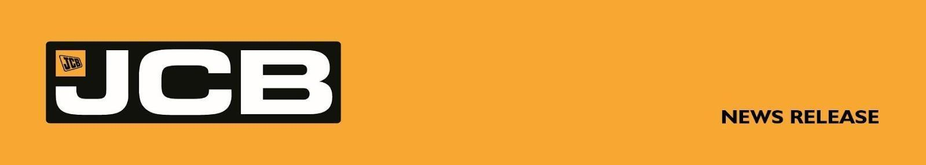
NC-5353 June 2026

SCOT AGRI SHOWCASES NEW JCB MACHINES AT ROYAL HIGHLAND SHOW

The new 335hp, all-wheel steer Fastrac 6300 will take centre stage at this year’s Royal Highland Show as JCB dealer Scot Agri showcases a comprehensive line-up of JCB farm equipment at Ingliston, Edinburgh from June 18-21.

Features include a new engine and stepless transmission combination, which is performance-matched to deliver smooth speed transitions and efficient power and torque delivery; and a comprehensive suite of factory-installed precision farming functions, including high-accuracy guidance.

The latter includes a choice of automated headland turn patterns and a unique twin satellite receiver installation that provides reliable accuracy, especially over rolling terrain.

The newcomer builds on JCB’s long-established formula for a tractor that can tackle field work as effectively as it can travel at high speed on the road, using its unique combination of suspension at both axles, powerful outboard disc brakes, four-wheel steering agility and 50:50 weight distribution to deliver high levels of productivity across a wide range of tasks.

For operators, the icing on the cake is the way all Fastracs – from the 235hp 4220 to the 348hp 8330 – provide an unparalleled level of comfort, both in the field where it encourages fast working speeds over rough surfaces, and on smooth and potholed roads, where the Fastrac 6300 can legally travel at up to 66kph.

Alongside the Fastrac 6300 and 4220 tractors, Scot Agri will illustrate the breadth and depth of the industry’s most comprehensive range of agricultural materials handling machines, with four JCB Loadall telescopic handlers destined for the Highland Show stand, ranging from the 1.4 tonne/4m 514-40 to the 4.2 tonne/7m 542-70.
More . . . .
2/ . . . .

Three examples of the Telemaster line-up are also being exhibited, including the diminutive but highly capable TM110, the smallest of its type in the range, yet capable of lifting 1.1 tonne at full articulation to 3.5m, and also the TM420S, the most powerful in the series at 173hp with a choice of 40kph or 50kph eight-speed powershift transmissions.

JCB’s newly-introduced mid-range TM280 is also set to make an appearance.

This 2.75 tonne to 4.8m machine comes in two guises – with a 109hp engine and three-speed 30kph hydrostatic drive or to ‘S’ spec with 130hp and a DualTech VT transmission.

The DualTech VT provides an effective and efficient combination of hydrostatic low-speed and direct mechanical high-speed drive up to 40kph – all in a highly agile package standing no more than 2.6m tall so that it can work in and around “traditional” farm buildings with low access.

ENDS
For further information contact: Nigel Chell, JCB Press Office
Tel: 01889 593592 E-mail: nigel.chell@jcb.com www.jcb.com

