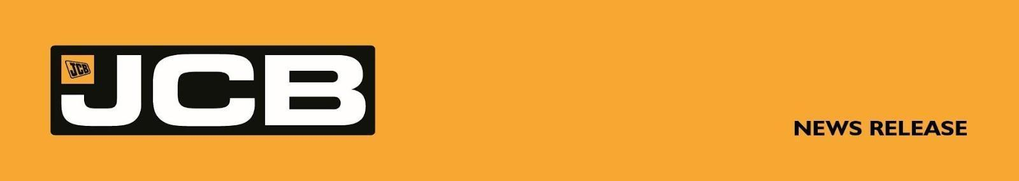
NC-5349 May 2026
JCB TARGETS NEW LAND SPEED RECORD USING ITS OWN HYDROGEN ENGINES
British engineering giant JCB is targeting a new land speed record with a 32-foot car powered by its own hydrogen engines.
The Staffordshire-based manufacturer, which employs more than 20,000 people worldwide, has spent five years developing hydrogen internal combustion engines as part of a £100 million investment. JCB diggers powered by the technology have just started rolling off production lines.
Now, exactly 20 years after rewriting the record books with the JCB Dieselmax car, the company is returning to the Bonneville Salt Flats in Utah to attempt a new speed record – this time using hydrogen power.
In August 2006, JCB Dieselmax, driven by Wing Commander Andy Green OBE, set a world diesel land speed record of 350.092 mph – a record that still stands. In August this year, Green will once again take the wheel, driving the hydrogen-powered JCB Hydromax. The JCB-led project is being supported by Prodrive and Ricardo.
JCB Chairman Anthony Bamford, who has spearheaded the company’s hydrogen programme, said: “Britain has a proud heritage of setting speed records and, as a British company, I’m excited to challenge for a new one using hydrogen. This is not just about speed – it’s about showcasing the world-class engineering talent we have here in the UK and the robustness of our new hydrogen engines.
“JCB Dieselmax was always a bit of an unusual idea – but it proved a point. Putting an advanced engine into a land-speed car showed the world what it could do in a way a digger never could. It’s the same thinking with hydrogen today. If you’re serious about emissions, you have to be serious about hydrogen – and a land-speed project is the perfect way to prove it.”
He added: “As for the speed, we’re aiming for with JCB Hydromax – we intend to beat 350 mph.”
Andy Green, the fastest man on earth at 763.035mph and the only person to break the sound barrier on land, said: “Twenty years ago, JCB took two of its diesel engines, sprinkled some magic engineering dust on them and put them into a racing car. We raced the JCB Dieselmax up to an astonishing speed - and a new FIA world record - of just over 350 mph. Today, that car is still the fastest diesel-engined vehicle in history. Now we're going back to the Bonneville Salt Flats, spiritual home of the World Land Speed Record, with JCB's new hydrogen engines.
More . . . .

2/ . . . .

“The 'JCB Hydromax' car is lighter, more powerful and faster than its predecessor of 20 years ago. Once again, we're going to show the world just how good British engineering and technology really is. This August we're going to smash the hydrogen-powered vehicle record in the world's fastest (and most exciting!) zero-emissions vehicle. I can't wait.”

Testing will begin in the UK before the team heads to Bonneville SpeedWeek, the world’s leading land speed racing event, where competitors from around the globe gather to chase records on the vast Salt Flats. JCB Hydromax will run with two production-based hydrogen engines, producing a combined 1,600 bhp. SpeedWeek is run by the Southern California Timing Association (SCTA), which governs and verifies official class records at the event.
The team will then remain at Bonneville to pursue officially recognised world records under the Fédération Internationale de l’Automobile (FIA), the global governing body for motorsport.
JCB’s speed attempt comes ahead of the opening of the company’s new $500 million, one million sq. ft, 400-acre factory in San Antonio, Texas, which will employ 1,500 people, manufacturing machines for the US market.
JCB has a long history of pushing the limits of speed. In 2019, the JCB Fastrac tractor was crowned the world’s fastest tractor at 135.191 mph, while in 2014 the JCB GT set the world record for the fastest backhoe loader at 72.58 mph.
ENDS
For further information contact:
Nigel Chell, JCB Press Office Tel: 01889 593592 Email: nigel.chell@jcb.com
About JCB
JCB, the world’s third largest construction equipment brand by volume, has 22 plants on four continents: 11 in the UK and others in India, Brazil, the USA and China. JCB is a family company, which was founded on October 23rd, 1945, by the late Joseph Cyril Bamford CBE. His son Anthony, now Lord Bamford, has been Chairman since 1975. JCB has just celebrated its 80th birthday.

In 2021, JCB unveiled its first ever prototype products powered by hydrogen: a backhoe loader and a Loadall telescopic handler. JCB’s purpose-engineered zero CO_{²} hydrogen engine was designed after a challenge to the company’s engineers from Lord Bamford. As part of a £100 million investment, a team of 150 engineers has been working on the exciting hydrogen engine project and more than 150 JCB hydrogen combustion engines have so far been produced, with the first machines now in production.

